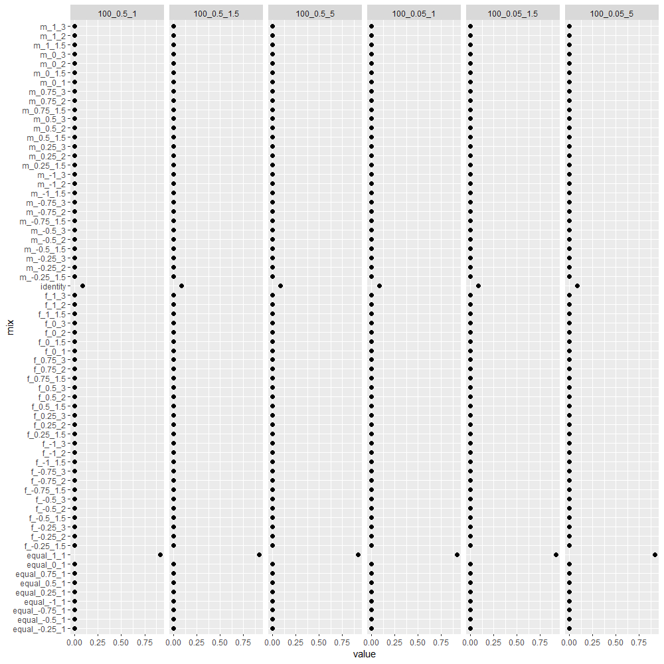

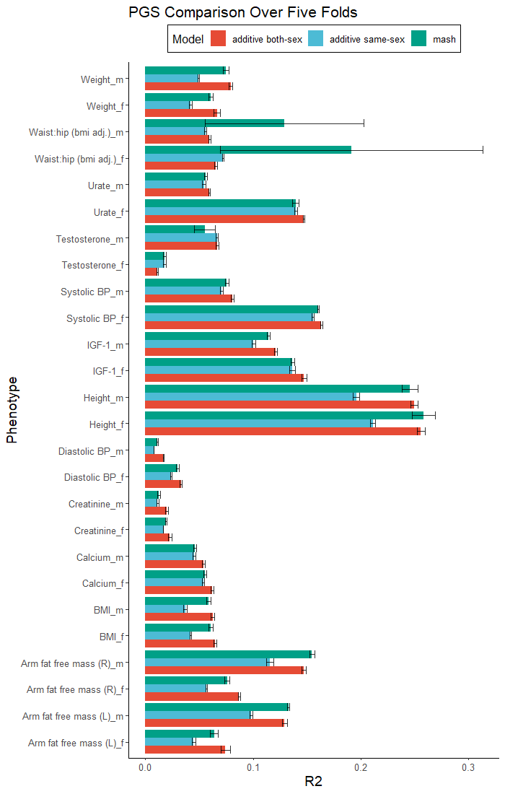

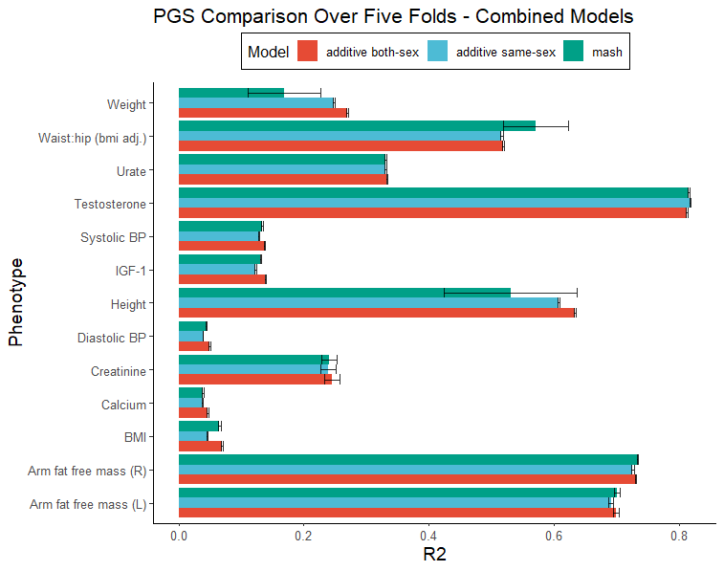

1. Sex stratified GWAS
   1. Testosterone
   2. IGF1, creatinine, whole body fat mass
2. Relative heritability by genetic correlation
3. Mash mixture weights
   1. M<F - M>F Weights by Trait ---supplement
4. M<F - M>F Weights by M:F Variance
5. M<F - M>F Weights by M:F Heritability
6. R2 v Phenotype over 5 folds
7. Additive Both-sex R2 to mash R2 by Female to Male heritability –-supplement
8. Correlation between Mean and Testosterone -- supp
9. Mean/Var v Testosterone ---literature search to see if its well known –supplement?
   1. BMI, arm fat free mass L, protein level, calcium
10. Correlation between Pheno~PGS and Testosterone
11. Pheno~PGS Testosterone
    1. BMI, arm fat free mass L, protein level, calcium
    2. One positive, one negative results
    3. 10 and 11 side by side to each other
    4. *** make corr pgs~pheno and testosterone plot by with slope instead of correlation
       1. Order by concordance of sign
       2. Significance
       3. Genetic correlation
       4. M-F difference magnitude
12. Simulation - Grid of Mixture Names (male, equal, female) by parameters

Literature search: Testosterone -> estrogen affect phenotype

Increase testosterone increase estrogen – more female side of the trait?

Labels

* Add both, mash, add
  + Additive
  + independent gwas – sex specific additive
  + Covariance aware

1. How effects covary in polygenic sense
   1. Figure 1: pipeline – Miami to mash mixture heat
      1. Flowchart figure: ‘Miami (mini figure)’ to ‘model polygenic covariance between males and females (text)’ to ‘Large covariance matrix (figure (below))’
      2. Actual covar matrix popping out from the large heat map one (couple of them)
      3. Then take big section of large heat map to show what goes into a box in the small heat map
      4. Show a few interesting examples (1 uninteresting case) – small
      5. Mash for binary

Relative heritability by genetic correlation

* Write correlation next to label
* Flip coordinates
* or log scale

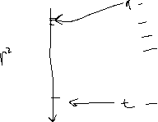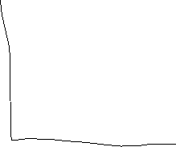

* Arrow with more genetically correlation (correlation in parenthesis)

Next Meeting

* New iteration of figure outline – sketch out some
* Simulation
* Other stuff (above)

More questions

* Variation within age group for testosterone? -research
* Ukbb estrogen –
* Evolutionary analysis, F_ST by mash effect size? Working with Matt

Conference???

* Submit abstract -> oral presentation
* Summary stats one site at a time for the simulation – sample and gwas then take together to put into mash
* Corr plot – line to divide every trait
* Manhattan plot – drop text, cut white spaces
* Mash plots
  + Infer weights of hypothesis matrices
  + Summarize qualitative covariance matrices
  + No effect weight (on bottom)
  + Remove color bar
  + Testosterone and calcium on right side, Manhattan plot on top
  + Show simpler covariance matrice
  + M and F to m and f, also on side of covariance matrice
* Mash weights for each variant – 3 traits
  + Cell type annotation
  + For all variants in certain annotation, look at average weight (where those weights are)
  + Testosterone, whole body fat mass, calcium